EXP NO: 1 - IDENTIFY A SOFTWARE SYSTEM THAT NEEDS TO BE DEVELOPED
PROJECT TITLE: Smart Canteen Management System
OBJECTIVE:
The objective of this system is to automate the canteen management process and reduce waiting time. It aims to provide easy food ordering, fast billing, and better management of menu items. The system also helps in maintaining accurate records and improving overall efficiency.
PROBLEM STATEMENT:
The traditional canteen system is manual and time-consuming, causing long queues and delays in service. There is no efficient way to manage orders, billing, and food availability. This leads to poor customer experience and increased workload for staff. Hence, a smart system is needed to automate canteen operations
SCOPE OF THE SYSTEM:
The system allows customers to view menus, place orders, and make payments online. It enables staff to manage orders and update their status efficiently. The admin can control menu items and monitor sales
  - Web-based or mobile-based application
  - Secure login system
  - Real-time order updates
  - Automated billing system
  - Database management for storing records

RESULT:
Thus, the implementation of the smart canteen Management System was successfully completed, and its objective, problem statement, and scope were clearly defined.
EX NO: 2 - DOCUMENT THE SOFTWARE REQUIREMENTS SPECIFICATION (SRS)
PROJECT TITLE: Smart Canteen Management System
MODEL USED: Waterfall model

PROJECT DESCRIPTION:
The Smart Canteen Management System (SCMS) is a web-based application designed to manage canteen operations such as food ordering, menu management, billing, and order tracking. It helps automate the traditional canteen process, reduces waiting time, improves efficiency, and provides a convenient platform for users to place and manage food orders online.

1. INTRODUCTION
The Software Requirement Specification (SRS) document describes the requirements of the Smart Canteen Management System (SCMS). This document is prepared based on IEEE 830 standards to identify, analyze, and define both functional and non-functional requirements of the system. It serves as a reference for designing and implementing the system using web technologies and object-oriented concepts.

1.1 PURPOSE
The Smart Canteen Management System (SCMS) is designed to automate canteen operations such as menu handling, food ordering, billing, and order management. The system aims to reduce manual effort, improve service speed, and enhance user experience.

1.2 SCOPE
- Allows users to view menu items, place orders, and track order status
- Provides admin functionalities for managing menu, prices, and orders
- Enables digital billing and payment processing
- Generates reports on sales, orders, and revenue
- Ensures secure access through user authentication

1.3 DEFINITIONS, ACRONYMS, AND ABBREVIATIONS
- SCMS – Smart Canteen Management System
- Admin – Canteen administrator with full system control
- User – Customer who orders food
- Order – Request placed by the user for food items

1.4 REFERENCES
- IEEE 830-1998 standard for Software Requirements Specification
- Unified Modelling Language (UML) diagrams

2. OVERALL DESCRIPTION
2.1 PRODUCT PERSPECTIVE
The Smart Canteen Management System is a standalone web-based application that manages menu items, food orders, billing, and user interactions.

2.2 PRODUCT FUNCTIONS
- User Registration & Login
- Menu Display and Management
- Food Ordering and Order Tracking
- Billing and Payment Processing
- Report Generation
2.3 USER CHARACTERISTICS
- Admin – Manages menu, prices, orders, and reports
- User – Views menu, places orders, and tracks order status
- Canteen Staff – Prepares food and updates order status

2.4 CONSTRAINTS
- The system must follow canteen operational rules
- Availability of food items depends on stock
- Online payment depends on third-party payment gateways

3. SPECIFIC REQUIREMENTS
3.1 FUNCTIONAL REQUIREMENTS
3.1.1 USER AUTHENTICATION
- The system shall allow users to register and log in using valid credentials

3.1.2 MENU MANAGEMENT
- The system shall allow the admin to add, update, and delete food items

3.1.3 FOOD ORDERING
- The system shall allow users to place orders based on menu availability

3.1.4 ORDER MANAGEMENT
- The system shall allow staff/admin to update order status (Preparing, Ready, Delivered)

3.1.5 BILLING AND PAYMENT
- The system shall generate bills and process payments

3.2 NON-FUNCTIONAL REQUIREMENTS
- The system shall support up to 300 concurrent users
- The response time shall be less than 2 seconds for order processing
- The system shall ensure data security and user privacy

3.3 INTERFACE REQUIREMENTS
HARDWARE INTERFACES
- User Device (Computer / Laptop / Mobile) – used by customers and admin
- Application Server – runs the Smart Canteen Management System
- Database Server – stores menu, user, and order data
- Network (Internet) – enables communication between users and the system

SOFTWARE INTERFACES
- Smart Canteen Application – main system managing canteen operations
- Admin Module – manages menu, orders, and reports
- User Module – allows users to browse menu and place orders
- Payment Gateway Module – processes online payments securely
- Authentication Module – handles login and security

DATABASE INTERFACES
- Menu Database – stores food items and prices
- User Database – stores customer details and login information
- Order Database – stores order details and status
- Payment Database – stores transaction and payment details

RESULT:
Thus, the Software Requirement Specification (SRS) for the Smart Canteen Management System was successfully prepared using the Spiral Model, and all system requirements were clearly identified and documented for implementation.

EXP NO: 3 - IDENTIFY USE CASES AND DEVELOP THE USE CASE MODEL
PROJECT TITLE: Smart Canteen Management System
DESCRIPTION:
- A Use Case Diagram is used to represent the interaction between users and system functionalities.
- It helps in identifying the functional requirements of the Smart Canteen Management System.
- The main actors identified are Admin, Staff, and Customer.
- The Admin performs use cases such as Login, Manage Menu, Manage Users, and Generate Reports.
- The Staff performs actions like View Orders, Prepare Food, and Update Order Status.
- The Customer performs use cases such as Register/Login, View Menu, Place Order, and Make Payment.
- Each use case represents a specific function provided by the system.
- The relationships between actors and use cases define the overall system behavior.
- The diagram helps in understanding the interaction flow and supports further system design.

USECASE DIAGRAM

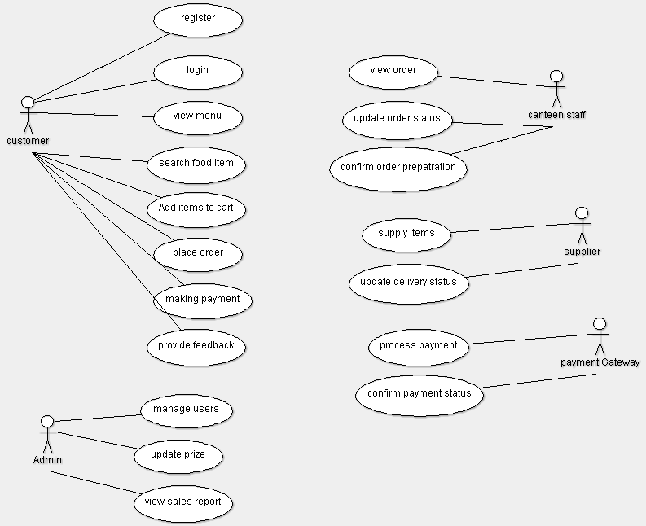

RESULT
Thus, the use cases such as Login, Manage Menu, Manage Users, Generate Reports, View Orders, Prepare Food, Update Order Status, View Menu, Place Order, and Make Payment were successfully identified, and the Use Case Model was developed using ArgoUML for the Smart Canteen Management System.
EXP NO: 4 - IDENTIFY THE CONCEPTUAL CLASSES AND DEVELOP A DOMAIN MODEL AND ALSO DERIVE A CLASS DIAGRAM FROM THAT
PROJECT TITLE: Smart Canteen Management System
DESCRIPTION:
- A Domain Model is used to identify the conceptual classes involved in the system and their relationships.
- It provides a high-level view of the Smart Canteen Management System without implementation details.
- The main conceptual classes identified are Admin, Staff, Customer, Order, Menu, Payment, and CanteenManagementSystem.
- These classes represent the key entities required for managing food ordering, billing, and canteen operations.
- The relationships between these classes such as managing, ordering, processing, and payment handling are defined in the model.
- From the Domain Model, a Class Diagram is derived by adding attributes and methods to each class.
- The Class Diagram represents the detailed structure of the system, which helps in Java-based implementation.

CLASS DIAGRAM
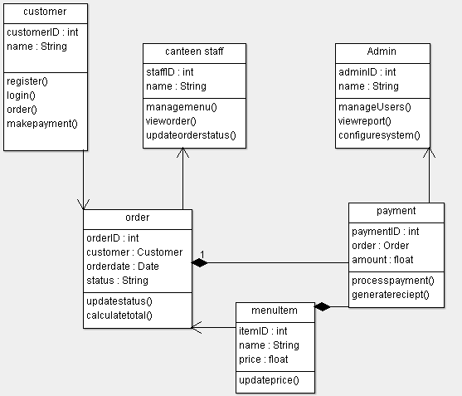

RESULT
Thus, the conceptual classes were identified, and the Domain Model and Class Diagram for the smart canteen Management System were successfully developed.
EXP NO: 5 - USING THE IDENTIFIED SCENARIOS, FIND THE INTERACTION BETWEEN OBJECTS AND REPRESENT THEM USING UML SEQUENCE AND COLLABORATION DIAGRAMS
PROJECT TITLE: Smart Canteen Management System
DESCRIPTION – SEQUENCE DIAGRAM
- A Sequence Diagram represents the interaction between objects in a time-ordered manner.
- It shows how messages are passed between objects step by step.
- In the Smart Canteen Management System, the main objects are Customer, CanteenSystem, Staff, and PaymentModule.
- The Customer initiates the process by logging in and selecting items using placeOrder().
- The CanteenSystem processes the request and sends order details to Staff using sendOrderDetails().
- The Staff prepares the order and updates the status using updateOrderStatus().
- The system then processes the payment through PaymentModule using processPayment().
- The payment confirmation is returned to the system and displayed as orderConfirmation().
- This diagram clearly shows the sequence of operations from order placement to successful delivery and payment completion.

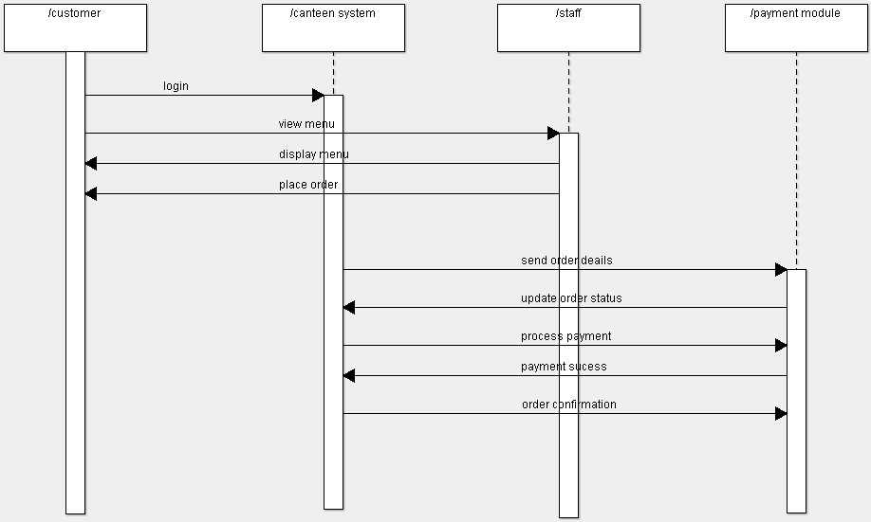

DESCRIPTION – COLLABORATION DIAGRAM
- A Collaboration Diagram represents the interaction between objects using message flow and numbering.
- It focuses on how objects are connected and communicate with each other.
- In the system, objects such as Customer, CanteenSystem, Order, Staff, and PaymentModule are involved.
- The interaction starts with the Customer sending a request to login and view the menu.
- The Customer then places an order, which is processed by the CanteenSystem and sent to Staff.
- The Staff prepares the order and updates the status in the system.
- The system then processes the payment through the PaymentModule and confirms the transaction.
- Finally, the system sends order confirmation to the Customer.
- Message numbers indicate the order of execution and relationship between objects.

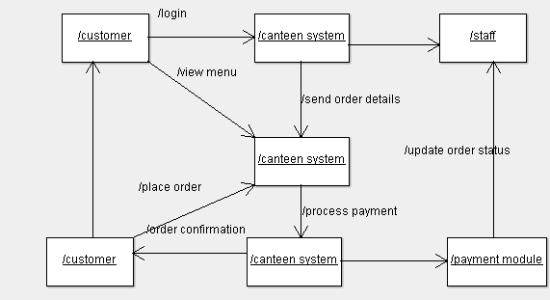

RESULT
Thus, the interaction between objects in the smart canteen Management System was successfully identified and represented using both Sequence and Collaboration Diagrams

